HALIFAX HAWKS
MINOR HOCKEY
ASSOCIATION
MONTHLY 50/50
FUNDRAISER

PARENTS “HOW TO” GUIDE

DECEMBER 2022
PREPARED BY HHMHA
IN PARTNERSHIP WITH RAFFLEBOX

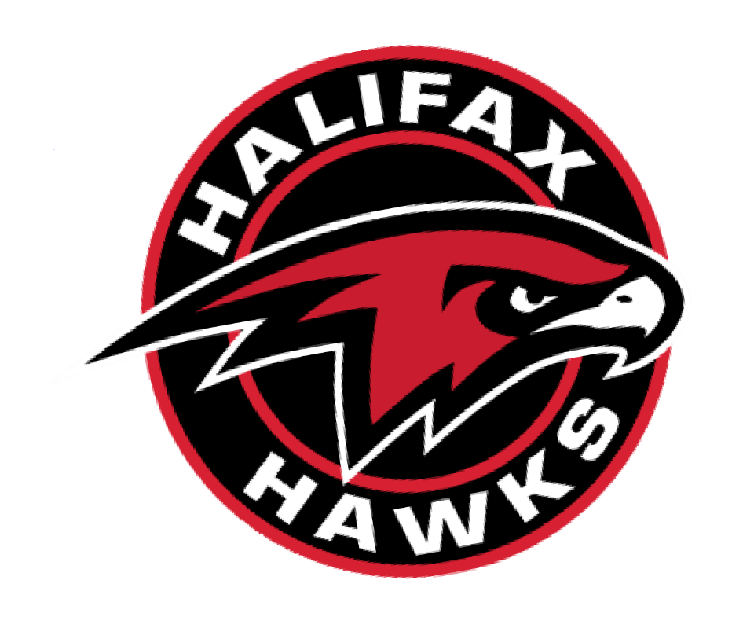

FUNDRAISING OVERVIEW 3
REVENUE BREAKDOWN 4
MONTHLY HYBRID 50/50 5
TOP FUNDRAISING PRIZES 5
DRAW INFORMATION 5
ONLINE TICKET SALES 6
PLAYER SELECT 6
TOP FUNDRAISER TAB 6

We are excited to launch our new 50/50 fundraising program fro 2022/23 that aims to help reduce registration costs for all of our players.
We’ve partnered up with Rafflebox who will provide the online platform to sell tickets, track sales, and market our 50/50 fundraiser to family and friends through the Province.
3

REVENUE SPLIT
HALIFAX
HAWKS
The remaining 14% goes to HHMHA to cover all the costs, fees and taxes.
HOCKEY
PLAYER
Each ticket a player sells contributes 36% towards their registration costs
50/50
WINNER
The lucky winner of our monthly 50/50 fundraiser gets 50% of each ticket sold
50%
36%
14%

HHMHA will track player sales each month and totaled at the end of the season to give a credit for next season. During the season we can provide individual player sales breakdown upon request.
Money raised by each player goes against their registration costs for the following season. The idea being to help reduce or eliminate registration fees for families all together!
We have a fully on line 50/50 fundraising model that allows for Online sales only. You will receive an e-mail to invite you to the website which you can share with friends and family.

Draw Information
The monthly draws will take place at Centennial Arena for at least December and January. If the day needs to be changed, it will be updated through or social media channels and at www.hawks5050.com.

Anyone in the province will be able to purchase tickets online for the 50/50 at: www.hawks5050.com.

Player Select
Our webpage has an “in support of” field where people can select which player the ticket purchases was in support of. The webpage tracks every sale and automatically updates the players total sales for the month under the ‘Top Fundraiser’ tab (see page 8).
There is an option to buy tickets just in support of the Hawks by not selecting any player. If you choose to do this all of the proceeds will go into the player support fund for next year.

Top Fundraiser Tab
The ‘Top Fundraiser’ tab tracks each players sales so you can see how much they have raised for the month (see page 8).

